What shall we do with the drunken sailor

What shall we do with the drunken sailor
Early in the morning!

Hooray and up she rises
Early in the morning!

Shave his belly with a rusty razor
Put him in a long boat till he’s sober
Stick him in a scupper with a hosepipe on him

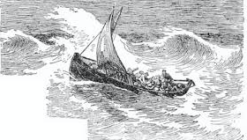

Skyeboat Song

Chorus
Speed, bonnie boat, like a bird on the wing,
Onward! the sailors cry;
Carry the lad that's born to be king
Over the sea to Skye.
Loud the winds howl, loud the waves roar,
Thunderclaps rend the air;
Baffled, our foes stand by the shore,
Follow they will not dare.
[Chorus]

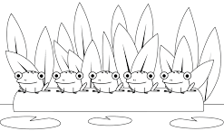

Five little speckled frogs
Five little speckled frogs
Sat on a speckled log
Eating some most delicious bugs, yum, yum
One jumped into the pool
Where it was nice and cool
Now there are four more speckled frogs, glub, glub
Four little speckled frogs
Sat on a speckled log
Eating some most delicious bugs, yum, yum
One jumped into the pool
Where it was nice and cool
Now there are three more speckled frogs, glub, glub
Three little speckled frogs
Sat on a speckled log
Eating some most delicious bugs, yum, yum
One jumped into the pool
Where it was nice and cool
Now there are two more speckled frogs, glub, glub
Two little speckled frogs
Sat on a speckled log
Eating some most delicious bugs, yum, yum
One jumped into the pool
Where it was nice and cool
Now there is one more speckled frog, glub, glub
One little speckled frog
Sat on a speckled log
Eating some most delicious bugs, yum, yum
One jumped into the pool
Where it was nice and cool
Now there are no more speckled frogs, glub, glub

Consider Yourself

Chorus
Consider yourself at home,
Consider yourself one of the family.
I’ve taken to you so strong
It’s clear we’re going to get along!
Consider yourself well in,
Consider yourself part of the furniture
There isn’t a lot to spare,
Who cares? Whatever we got to share!

If it should chance to be
we should see some harder days
Empty larder days, why grouse?
If there’s a chance we’ll meet
somebody to foot the bill,
Then the drinks are on the house!

Consider yourself, our mate
We don’t want to have no fuss
For after some consideration we can state,
Consider yourself one of us!

Chorus

Nobody tries to be lah-di-dah and uppity,
There’s a cup o’ tea for all,
Sometimes it’s wise to be
Handy with a rolling pin,
When the landlord comes to call!
Consider yourself, our mate
We don’t want to have no fuss
For after some consideration we can state,
Consider yourself one of us!

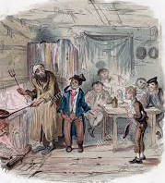

Sisters

Sisters, sisters
There were never such devoted sisters,
Never had to have a chapter one “No Sir!”
I’m there to keep my eye on her.
Caring, sharing
Every little thing that we are wearing.
When a certain gentleman arrived from Rome,
She wore the dress and I stayed home.

All kinds of weather, we stick together,
The same in the rain and sun,
Two diff’rent faces, but in tight places
We think and act like one.
Those who’ve seen us
Know that not a thing could come between us,
Many men have tried to split us up
But no-one can.
Lord help the Mister who comes between me and my sister
And Lord help the sister
Who comes between me and my man.

